**Laboratory no. 2**

1. In the lab you will create Ethernet Network, connect it to the Router and set up IP addresses. To configure router, you could use the Command Line Interface (CLI). You have to create two networks like in a picture bellow.

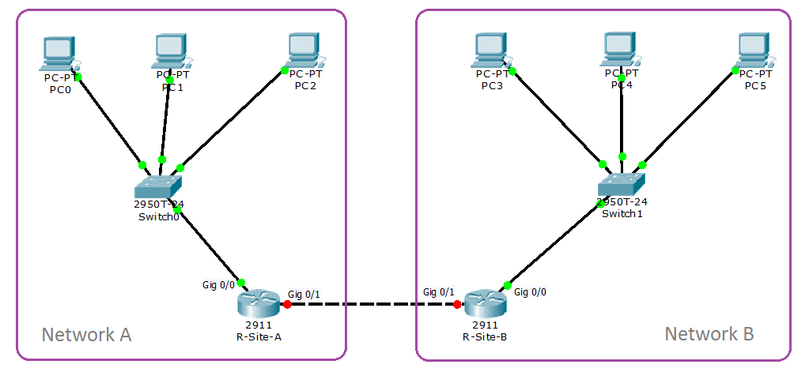

**Part1 – create networks**

In this part, you work in network simulation program. You have to create two networks.

* To create “Network A” you have to fill all steps from paragraph 1.
* For “Network B” you have only network values and need to create network like “Network A”.

1. **Create the network “Network A”**.

Open a program “Cisco Packet Tracer”. Drag into workplace:

* From “End Devices” selection box – 3 computers(Generic PC);
* From “Switches” selection box – switch (2950T);
* From “Routers” selection box – router (2911).

**Connect computers PC0, PC1 and PC2 to switch “Switch0”**.

Connect PCs to a switch by the “Copper Straight-Through” cable from the Cable selection Box. For this action, choose the cable (Copper Straight-Through), click onto PC and connect by cable FastEthernet0 on PC with one of FastEthernet’s port on switch “Switch0.

**Connect switch “Switch0” to Router “Router0”**.

By the cable “Copper Straight-Through” connect the switch (interface Gigabitethernet 1/1) with router “Router0” GigabitEthernet 0/0.

**Connecting and configure the router (change the router name)**.

To rename routers Router0 to R-Site-A. Have to double click on the router, choose tab “CLI” and wait when the router finished load software and start work. On prompt “*Continue with configuration dialog? [yes/no]:*” choose “No”. Twice enter “Return” when you see, in left bottom corner, prompt “**Router>**”.

* Enable privileged EXEC mode, execute command *enable*.
* Enter the Global Configuration Mode, execute command *configure terminal* (shot form *conf t*).
* Use the command: *hostname <new_name>*, change Router to new name R-Site-A (without brackets < >)*.*

Write the commands with **router prompt**:

Router>enable

Router#configure terminal

Enter configuration commands, one per line. End with CNTL/Z.

Router(config)#hostname R-Site-A

R-Site-A(config)#

Router>enable

Router#conf t

Enter configuration commands, one per line. End with CNTL/Z.

Router(config)#hostname R-Site-B

R-Site-B(config)#

On “Config” tab change field “Display Name” to R-Site-A, and back to “CLI” tab.

**Configuring the interface GigabitEthernet 0/0 on router “R-Site-A”**.

For interface GigabitEthernet 0/0 set an IP address *192.168.10.1* with network mask *255.255.255.0*. Bring this interface to status up (enable).

To configure interface

* From Global Configuration Mode settings enter to the Interface Configuration Mode (router(config-if)#) , execute the command *interface GigabitEthernet 0/0*.
* To set up IP address use the command: *ip address 192.168.10.1 255.255.255.0*.
* To bring interface to status up use the command: *no shutdown*.

Write the commands with **router prompt**:

R-Site-A(config)#interface GigabitEthernet0/0

R-Site-A(config-if)#ip address 192.168.10.1 255.255.255.0  
R-Site-A(config-if)#no shutdown

R-Site-A(config-if)#

%LINK-5-CHANGED: Interface GigabitEthernet0/0, changed state to up

%LINEPROTO-5-UPDOWN: Line protocol on Interface GigabitEthernet0/0, changed state to up

Close the window.

**Configuring the IP address on computer PC**.

For computers PC0, PC1 and PC2 set up IP addresses *192.168.10.[10÷12]*, network mask *255.255.255.0* with default gateway *192.168.10.1*.

To set up IP address click on computer icon, go to “Desktop” tab and use “**IP configuration**” icon to bring the configuration utility. Choose the **Static** button to set the IP address manually.

Check the connection between a PC and the router (default gateway).

1. **Create the second networks (Network B)**.

Create a network with three computers connected to switch and communicated with router (like in previous paragraph).

You have to:

* Change router name to new name R-Site-B.
* To interface on the router “R-Site-B”, to which connected the switch, set up IP Address 192.168.11.1 with network mask 255.255.255.0, and bring it to status up.
* For computers (PCs) set up IP addresses *192.168.11.[10÷12]*, network mask *255.255.255.0* with default gateway *192.168.11.1*.
* Check the communication between computers and router. If some communication problem available, you have to fix it.

**Check configuration of the router**.

On router, you need enter to the **privilege EXEC mode** (router#).

To view **interfaces list** installed on the router use the command: *show ip interface brief*.

Put the output result here:___

R-Site-B#show ip interface brief

Interface IP-Address OK? Method Status Protocol

GigabitEthernet0/0 192.168.11.1 YES manual up up

GigabitEthernet0/1 unassigned YES unset administratively down down

GigabitEthernet0/2 unassigned YES unset administratively down down

Vlan1 unassigned YES unset administratively down down

What is the IP address for interface GigabitEthernet 0/0: _____192.168.11.1_______

What is the IP address for interface GigabitEthernet 0/1: ______unassigned________

What is the IP address for interface GigabitEthernet 0/2: ______unassigned________

R-Site-A#show ip interface brief

Interface IP-Address OK? Method Status Protocol

GigabitEthernet0/0 192.168.10.1 YES manual up up

GigabitEthernet0/1 unassigned YES unset administratively down down

GigabitEthernet0/2 unassigned YES unset administratively down down

Vlan1 unassigned YES unset administratively down down

What is the IP address for interface GigabitEthernet 0/0: _____192.168.10.1_______

What is the IP address for interface GigabitEthernet 0/1: ______unassigned________

What is the IP address for interface GigabitEthernet 0/2: ______unassigned________

To view **router configuration** which now run on the router use the command: *show running-config*. On the bottom of screen you can see pattern “--More--“, this means that available more output information. To see this information use the “Space bar” or “Enter” key.

Put the output result here (only section with the router name and interfaces settings):___

!

hostname R-Site-A

!

interface GigabitEthernet0/0

ip address 192.168.10.1 255.255.255.0

duplex auto

speed auto

!

interface GigabitEthernet0/1

no ip address

duplex auto

speed auto

shutdown

!

interface GigabitEthernet0/2

no ip address

duplex auto

speed auto

shutdown

!

hostname R-Site-B

!

interface GigabitEthernet0/0

ip address 192.168.11.1 255.255.255.0

duplex auto

speed auto

!

interface GigabitEthernet0/1

no ip address

duplex auto

speed auto

shutdown

!

interface GigabitEthernet0/2

no ip address

duplex auto

speed auto

shutdown

!

**Part2 – Create an Ethernet network (physical into laboratory room)**

In this part of laboratory work, we will have to build and configure the simple network connected to Router. We will connect two computers and Router’s interface to the switch. Assign relevant IP addresses to computers and router’s interface. Finally check connections between computers and Router.

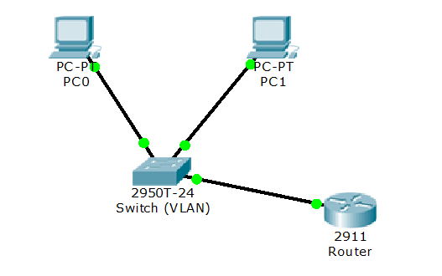

לפני תחילת העבודה, נתקין את ה FEATURE שנקרא Telnet client:

לחצו start והקלידו programs and features, כנסו לאופציה הראשונה.

לחצו בצד שמאל על turn windows features on or off

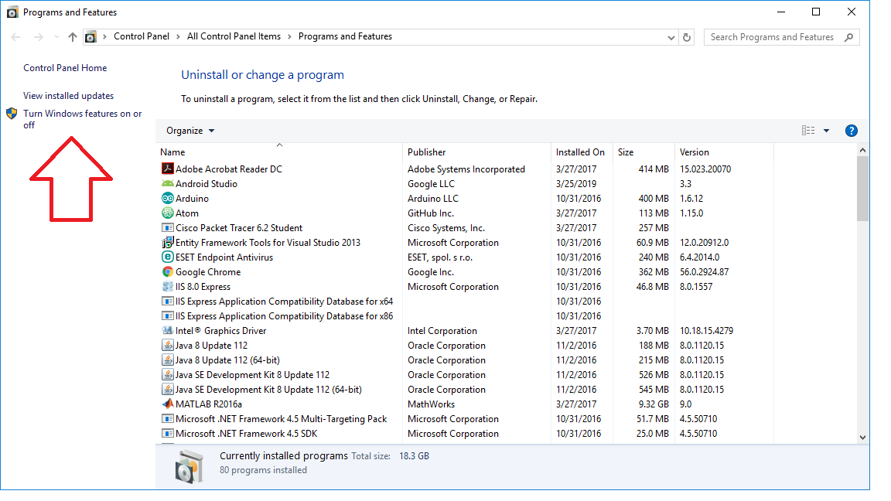

בחלון שנפתח, בחרו באופציה telnet client ולחצו OK

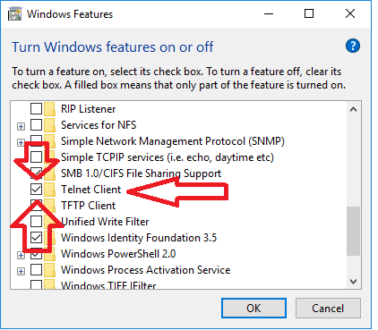

1. **Define the network properties**.

Your computer have to use IP address by template: IP address from range **192.168.X.[2_253]** with network mask **255.255.255.0** and default gateway **192.168.X.1**. Where X is in range 31 – 35 and this is a VLAN number.

Fill the values:

הסבר קטן:

1. בוחרים SWITCH שאליו רוצים להתחבר. ל SWITCH יש 2 VLAN, בוחרים אחד מהם.

VLAN id number. _____34____

1. לפי הVLAN, בוחרים כתובת IP לפי הפורמט המתואר למעלה **192.168.X.[2_253]**

IP address: ________192.168.34.11_______

ולפי ה VLAN מקבלים את כתובת ה DEFAULT GATEWAY -- **192.168.X.1**.

Network mask: _____255.255.255.0_______

Default gateway: _____192.168.34.1_____

From the table below chose values, depend which VLAN your network connected.

|  |  |  |  |
| --- | --- | --- | --- |
| **VLAN ID** | **Router Name** | **Interface name** | **Access IP address** |
| 31 | R-Main | GigabitEthernet 0/0 | 192.168.50.1 |
| 32 | R-Site-A | GigabitEthernet 0/1 | 192.168.51.254 |
| 33 | R-Site-A | GigabitEthernet 0/2 | 192.168.51.254 |
| 34 | R-Site-B | GigabitEthernet 0/1 | 192.168.52.254 |
| 35 | R-Site-B | GigabitEthernet 0/2 | 192.168.52.254 |

Fill the values:

שימו לב, לפי ה VLAN שבחרתם, תדעו לאיזה ראוטר אתם עומדים להתחבר.

Router Name: _______R-Site-A__________

Interface Name: ______ GigabitEthernet 0/1_________

**Important**:

Before disconnect your working computer you need configure the router, depend on VLAN that you work. Configure the router, disconnect the PC and connect it to the switch. Set up IP address for PC and check connection between PC and Router.

Router’s interface connected to switch, which you work, by black cable with label. On the label written router name and interface number. Label like R-Site-A, Gig 0/0 said that your computer connect to router “R-Site-A” and interface number GigabitEthernet 0/0.

או במילים אחרות:

קודם בצעו את ההגדרות, אחר כך נתקו את הכבל מהסוויץ' ותחליפו לסוויץ' אחר.

1. **Network creation**.
2. Connect to router with a telnet client. In “Run” window type *telnet <IP_Address>*, where *<IP_Address>* is address of column “Access IP address, from the table above (paragraph 2.1). Use username *student5* and password *braude5*.
3. To view **interfaces description** installed on the router use the command: *show interface description* from the “Privilege Exec Mode” (Router#).

Put the output result here:___

R-Site-A#show interface description

Interface Status Protocol Description

Em0/0 admin down down

Gi0/0 up up "Connect R-Main (Gig 0/1)"

Gi0/1 up up "Sw-Site-A (VLAN-34)"

Gi0/2 up up Network-A

Gi0/0/0 up up

Gi0/0/1 up up

Gi0/0/2 up up

Gi0/0/3 down down

Vl1 up up

1. Router interface, which defined in table 2.1 for your network, used as default gateway for network to where your computer works. Set up IP address to this interface and bring it to status up. Use the value that you define as “Default gateway” in paragraph 2.1, and commands form part1.

כאן תשתמשו בהגדרה של configure terminal, ל interface שמתאר את הגישה לראוטר הרלוונטי אליכם.

ב interface תגדירו את כתובת הIP ואת המסיכה ולא לשכוח לכתוב no shutdown.

Write the commands, with the router prompt:

R-Site-A(config)#interface Gig0/1

R-Site-A(config-if)#ip address 192.168.34.1 255.255.255.0

R-Site-A(config-if)#no shutdown

1. Check the router settings. On router, you need enter to the **privilege EXEC mode** (router#). To view **interfaces list** installed on the router use the command: *show ip interface brief*. Check that IP address for your ”Default gateway” interface correct.

Put the output result here:___

R-Site-A#show ip interface brief

Interface IP-Address OK? Method Status Protocol

Embedded-Service-Engine0/0 unassigned YES NVRAM administratively down down

GigabitEthernet0/0 192.168.51.254 YES NVRAM up up

GigabitEthernet0/1 192.168.34.1 YES manual up up

GigabitEthernet0/2 192.168.33.1 YES manual up up

GigabitEthernet0/0/0 unassigned YES unset up up

GigabitEthernet0/0/1 unassigned YES unset up up

GigabitEthernet0/0/2 unassigned YES unset up up

GigabitEthernet0/0/3 unassigned YES unset down down

Vlan1 192.168.10.1 YES NVRAM up up

1. Disconnect your computer form switch “Sw-Main” and connect it to switch belong to VLAN that your computer need works.

עכשיו מחברים את הכבל לSWITCH שבחרנו ב VLAN שבחרנו.

1. Set IP address on your computer. Open “Network and Sharing Center” (Control Panel -> Network and Internet -> Network and Sharing Center). Choose the network interface “Local Area Connection” and set up IP address from paragraph 2.1.

בחלון הרשתות, בחרו את ETHERNET וכנסו למאפיינים. לחצו פעמיים על Internet protocol version 4 (זו הגדרת ה IP) . בחרו use the following IP address ומלאו את השדות:

IP – הכתובת שבחרתם בסעיף 2.1

SUBNET MASK – מה שהגדרתם בסעיף 2.1

Default gateway – מה שהגדרתם בסעיף 2.1

1. **Check the communication**.

Check the communication between computer and computer default gateway (Interface on router). Use the command ***ping***.

שלחו פינג לראוטר הרלוונטי מהטבלה בסעיף 2.1.

Put Screen capture window with ping command result (use alt + PrtScn)

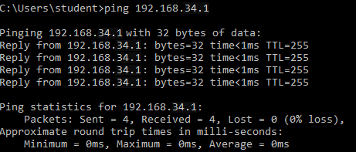

1. **Return the communication back**.

Connect back your computer to the switch “Sw-Main” and set up IP address to “Local Area Connection” automatically.

Send to check two files (this Word document and file of network simulation).